Table of Contents:

1. Introduction

2. System Requirements

3. Raspberry Pi 5 Support

4. Installation Guide

5. Main Features

6. User Interface Guide

7. Button Functionalities

8. Customization Options

9. Troubleshooting

Introduction

This application is designed to help you manage and create custom cocktails using a sophisticated ingredient management system and automated mixing capabilities.

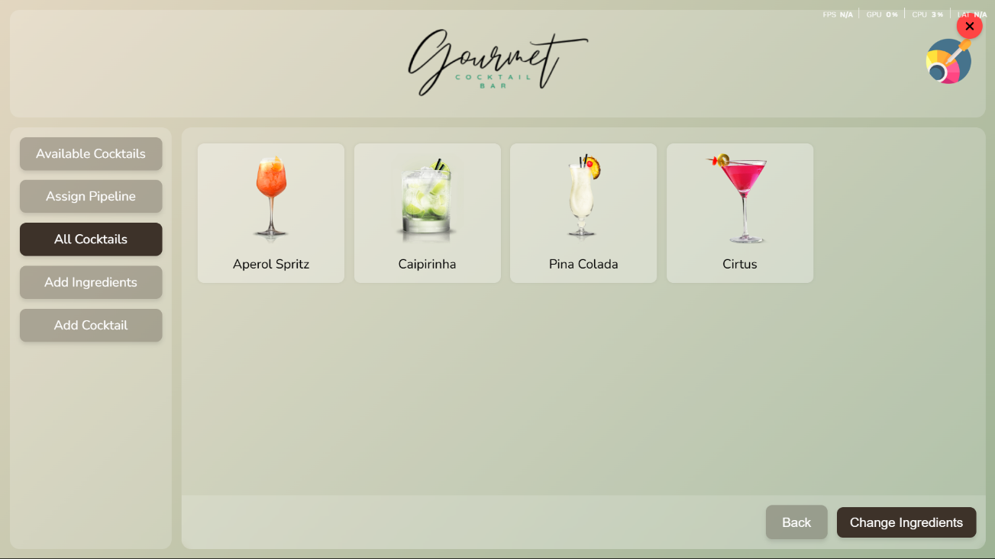

System Requirements

- Operating System: Raspberry Pi 5

- Python 3.x

- Node.js and npm (for Electron)

- Serial port access (for hardware communication)

- Minimum 4GB RAM

- 500MB free disk space

Raspberry Pi 5 Support

The application is fully compatible with Raspberry Pi 5 running Linux. Here are the specific requirements and setup instructions:

Hardware Requirements:

- Raspberry Pi 5 (4GB or 8GB RAM recommended)

- USB Serial Adapter (if using external serial device)

- HDMI Display

- USB Keyboard and Mouse

- Power Supply (5V/5A recommended)

Linux Setup Commands:

1. Update system packages:

sudo apt update && sudo apt upgrade -y

2. Install required dependencies:

sudo apt install -y python3-pip nodejs npm git

3. Install Python packages:

pip3 install pyserial

4. Set up serial port permissions:

sudo usermod -a -G dialout $USER

sudo chmod 666 /dev/ttyUSB0 # Replace ttyUSB0 with your actual port

5. Configure display (if using HDMI):

sudo raspi-config

# Navigate to Display Options > Resolution

# Select your preferred resolution

6. Enable required interfaces:

sudo raspi-config

# Enable I2C, SPI, and Serial interfaces

7. Set up auto-start (optional):

sudo nano /etc/xdg/autostart/cocktail-mixer.desktop

# Add the following content:

[Desktop Entry]

Type=Application

Name=Cocktail Mixer

Exec=/usr/bin/python3 /path/to/your/app.py

X-GNOME-Autostart-enabled=true

8. Monitor system resources:

# Check CPU temperature

vcgencmd measure_temp

# Monitor CPU usage

top

# Check memory usage

free -h

# View system logs

journalctl -u cocktail-mixer

Troubleshooting Raspberry Pi:

1. Serial Port Issues:

ls -l /dev/tty* # List available serial ports

dmesg | grep tty # Check kernel messages for serial devices

sudo chmod 666 /dev/ttyUSB0 # Fix permissions if needed

2. Display Issues:

tvservice -s # Check display status

tvservice -p # Power on HDMI

tvservice -o # Power off HDMI

3. Network Issues:

ifconfig # Check network interfaces

ping 8.8.8.8 # Test internet connectivity

hostname -I # Show IP address

4. System Monitoring:

htop # Interactive process viewer

iotop # Monitor disk I/O

vcgencmd get_throttled # Check for throttling

Installation Guide

1. Clone the repository

2. Install Python dependencies:

pip install -r requirements.txt

3. Install Node.js dependencies:

npm install

4. Run the application:

python app.py

Main Features

- Ingredient Management

- Cocktail Creation

- Pipe Assignment

- Real-time Hardware Communication

- Customizable Interface

- Cocktail Database Management

User Interface Guide

Main Navigation:

The application has several main sections accessible through the navigation buttons:

1. Find Cocktail

- Search and select ingredients

- View available cocktails

- Filter ingredients by type

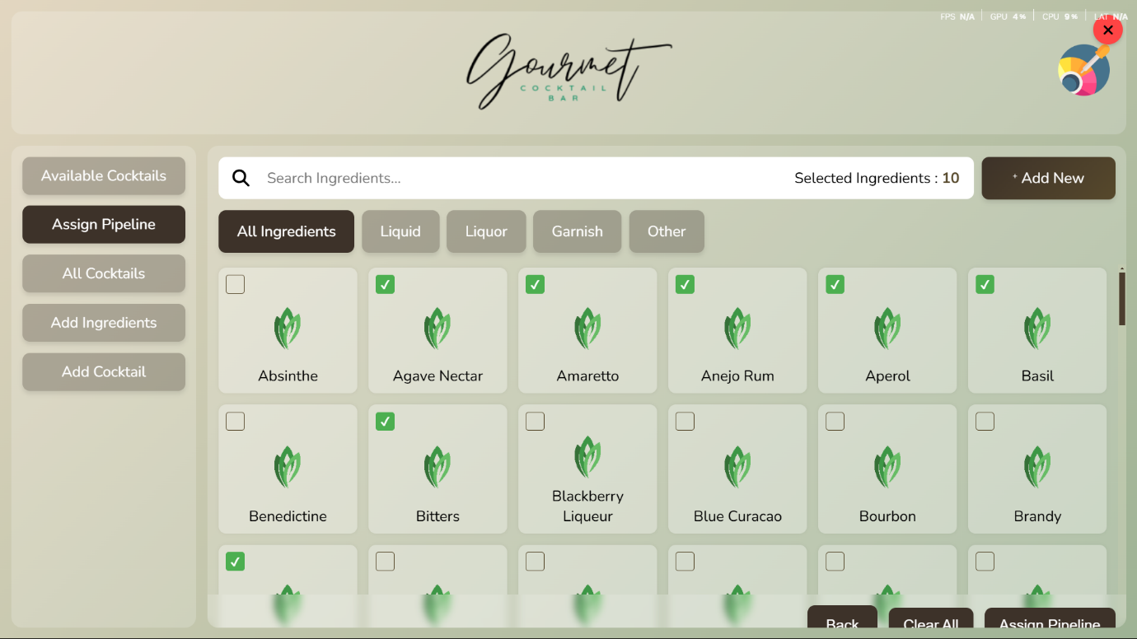

2. Add Ingredients

- Add new ingredients to the database

- Upload ingredient images

- Set ingredient properties

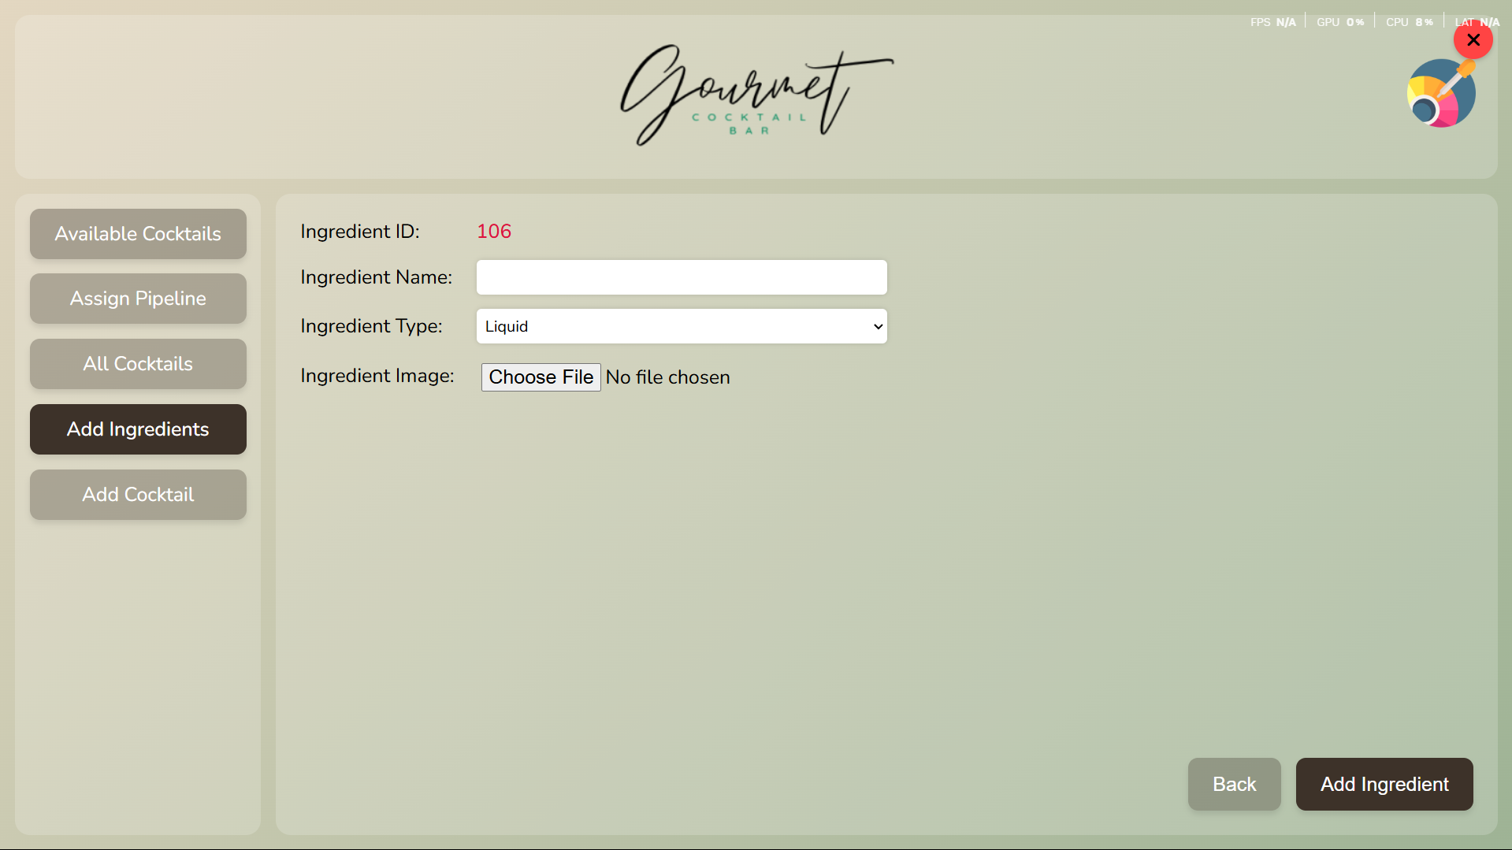

3. Add Cocktail

- Create new cocktail recipes

- Define ingredient proportions

- Set cocktail properties

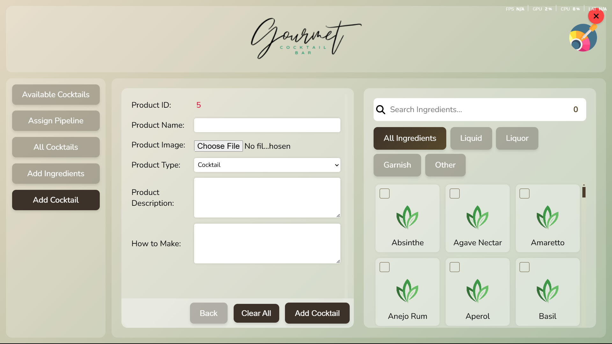

4. All Cocktails

- View complete cocktail database

- Search and filter cocktails

- Edit existing cocktails

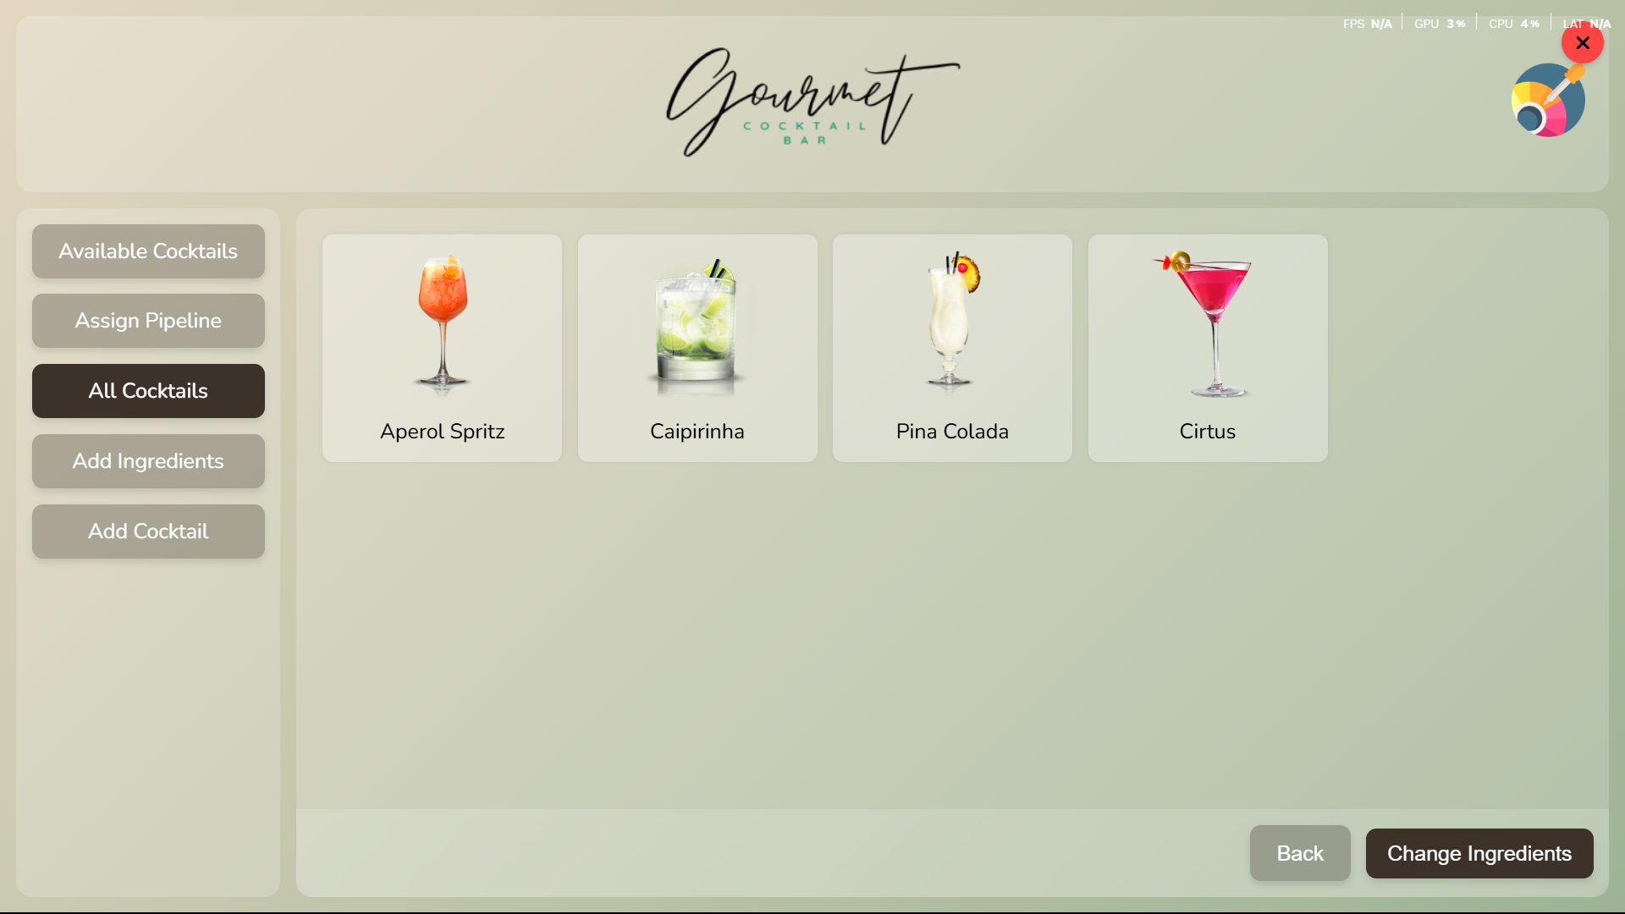

5. Cocktail Details

- View detailed information about cocktails

- See ingredient lists

- View preparation instructions

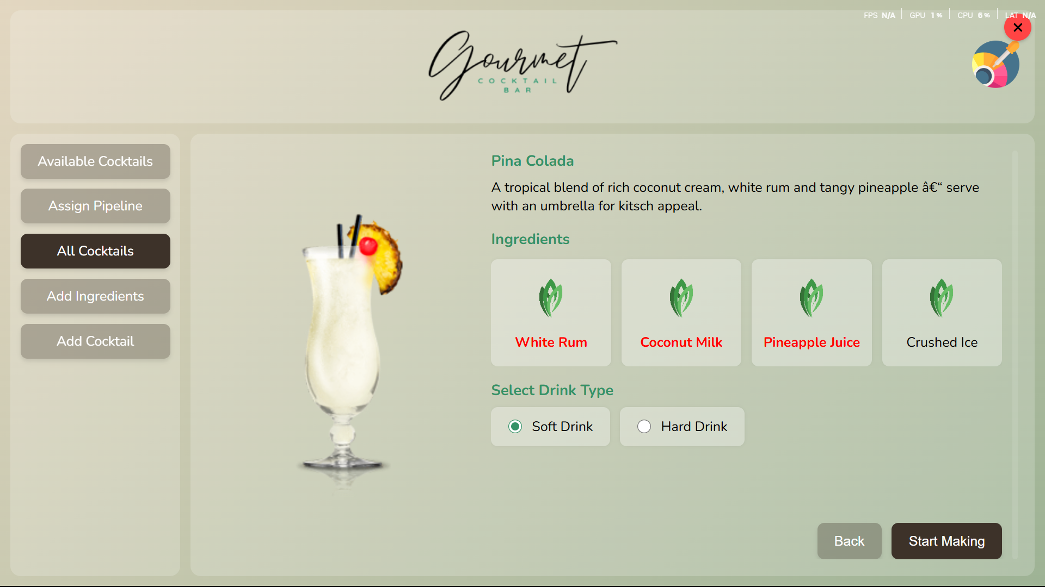

6. Available Cocktails

- See cocktails that can be made with current ingredients

- Check ingredient availability

- Select cocktails for preparation

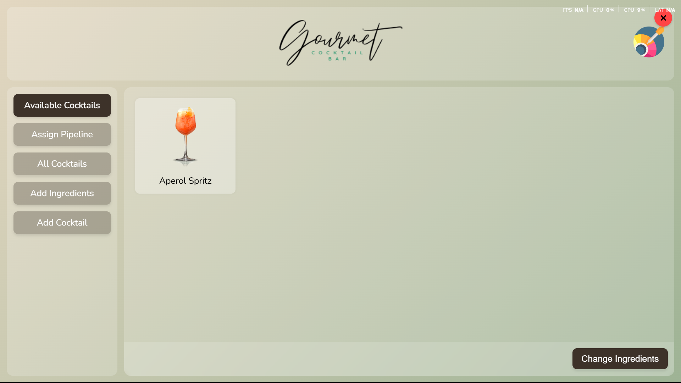

7. Assign Pipe

- Configure pipe assignments

- Set up ingredient-to-pipe mapping

- Save pipe configurations

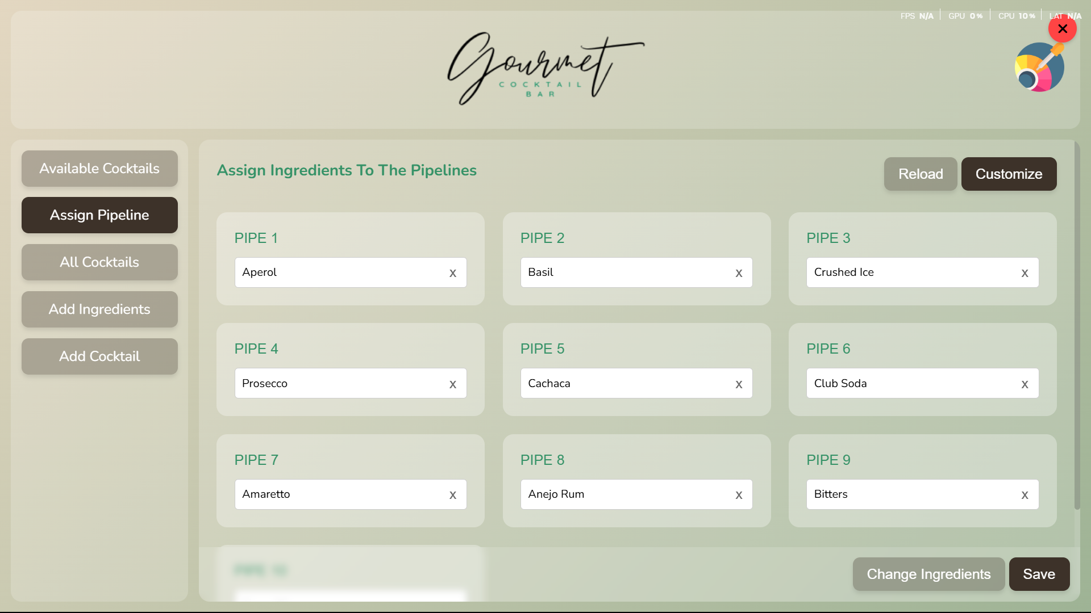

Button Functionalities

Main Navigation Buttons:

-Change Ingredients: Opens ingredient search and selection interface

- Add Ingredients: Opens new ingredient creation form

- Add Cocktail: Opens new cocktail creation form

- All Cocktails: Shows complete cocktail database

- Cocktail Details: Displays detailed cocktail information

- Available Cocktails: Shows possible cocktails with current ingredients

- Assign Pipe: Opens pipe configuration interface

Action Buttons:

- Search: Filters ingredients or cocktails based on input

- Clear All: Removes all selected ingredients

- Customize: Opens interface customization options

- Generate: Creates pipe assignments

- Save: Stores current configuration

- Back: Returns to previous screen

Customization Options

The application offers several customization features:

1. Interface Colors:

- Button background colors

- Button hover colors

- Text colors

- Background colors

2. Pipe Configuration:

- Number of pipes (1-100)

- Pipe-to-ingredient mapping

- Default configurations

Troubleshooting

Common Issues and Solutions:

1. Serial Port Connection:

- Check if the correct port is selected

- Verify hardware connection

- Restart the application

2. Image Processing:

- Ensure images are in supported formats

- Check file permissions

- Verify storage space

3. Database Issues:

- Check file permissions

- Verify JSON file integrity

- Restart the application

*For additional support or questions, please contact the system administrator.*

*Note: This documentation is subject to updates and improvements. Please check for the latest version.*